Lab Assignment 2 – Developing Mobile Web App

Vinutha Nuchimaniyanda

Restaurant Mobile Web App

The Restaurant Mobile Web app uses HTML5, JavaScript, CSS, and jQuery Mobile 1.3.0b1 and Google maps API.

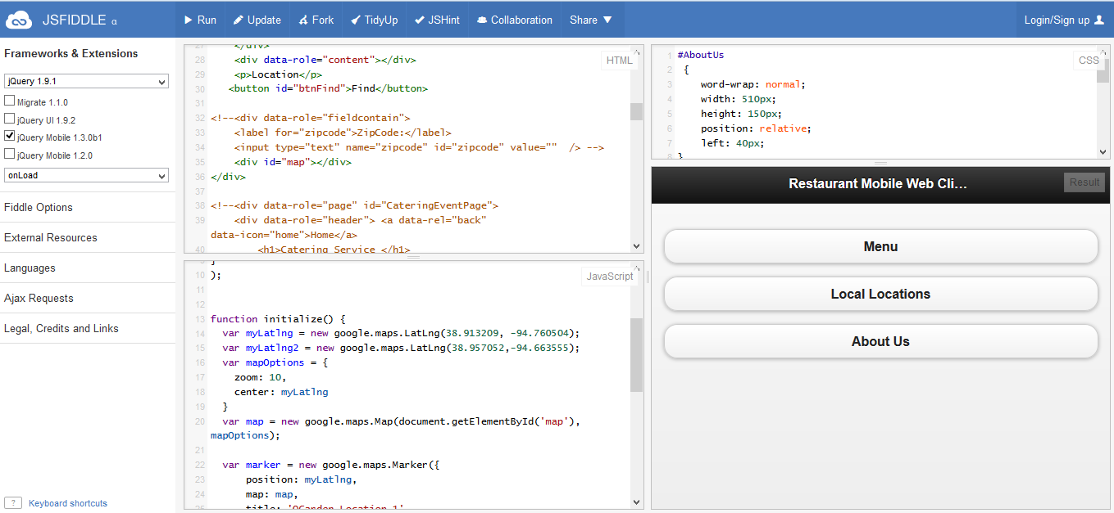

Display with Opera Mobile Emulator

This app includes three main options.

1. Menu – Displays menu items
2. Location- Displays the current Location and provides directions.
3. About Us- General Information about the restaurant

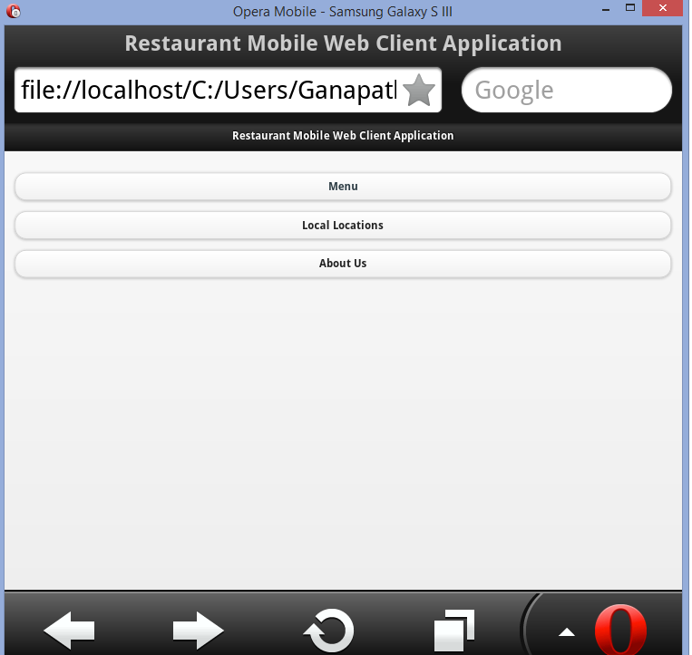

Menu page includes 4 buttons with popup button displaying the items and hover function with Main Course popup. Home button is used to go back to the main page.

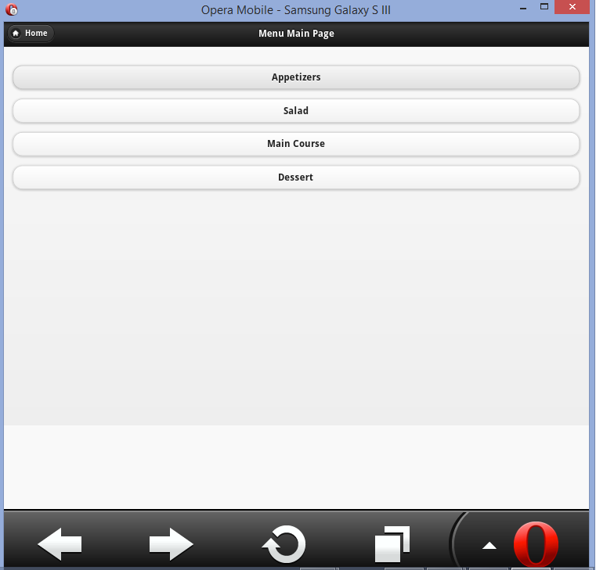

List’s the items with a popup.

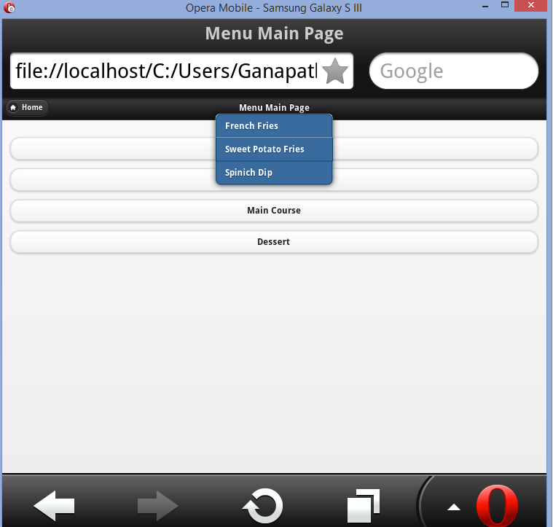

Main Course popup with hover function.

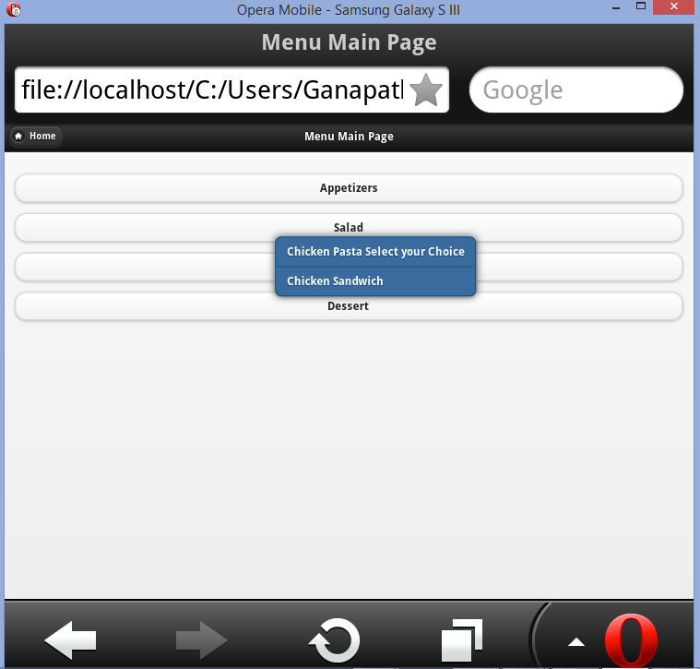

Image included with the Dessert. Home button is used to go back to the main page.

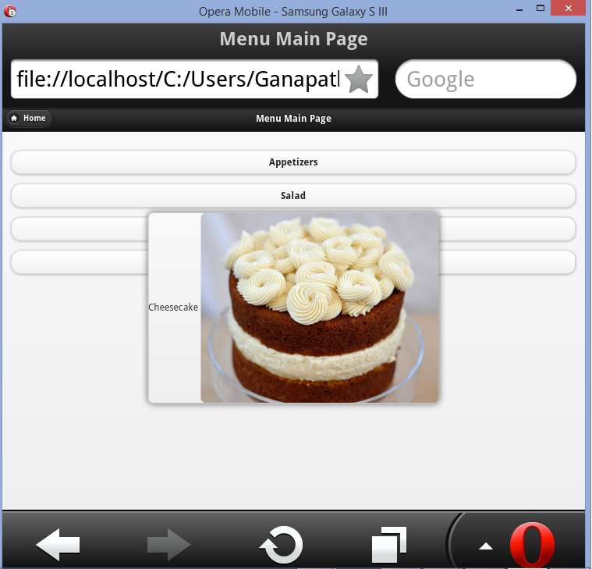

Local Location uses google map API and displays the current Location using Longitude and Latitude. Home button is used to go back to the main page. By clicking Show Location, a map will be displayed for current locations.

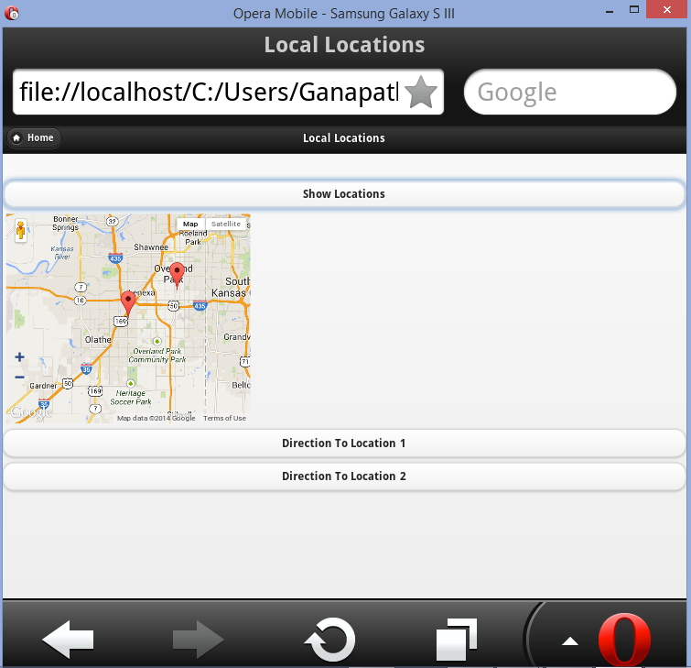

Direction to location 1 uses Direction service Api from google maps. It displays the directions to the first location.

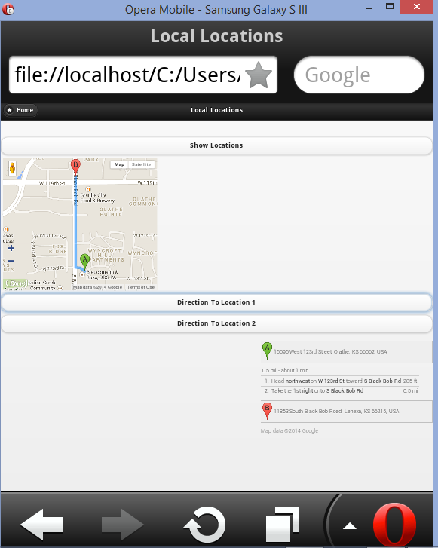

Direction to location 2 uses Direction service API from google maps. It displays the directions to the second location.

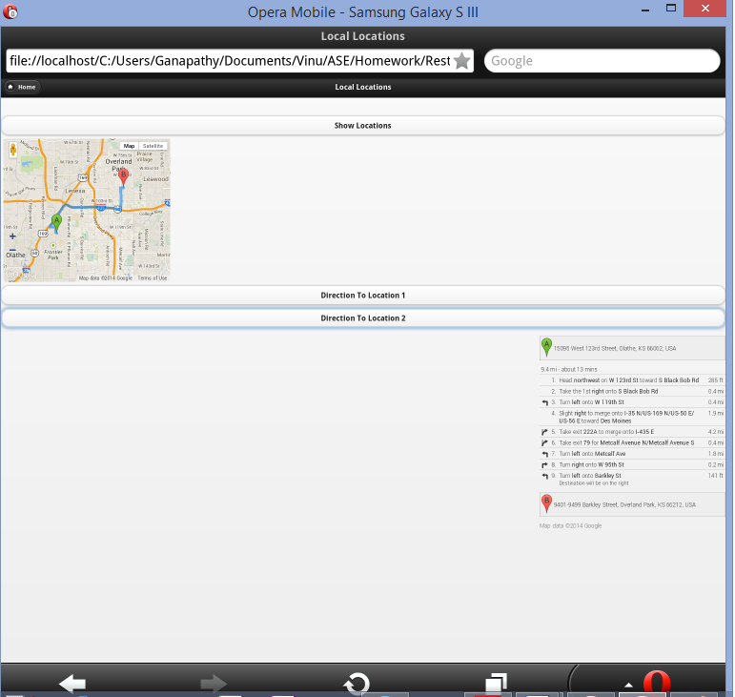

About us displays the general information about the restaurant in a textbox. Home button is used to go back to the main page.

